## CH 1~7 Review Quiz Name:_________

1. 英文用語測驗
2. Look forward to
3. By the way
4. Because

因果

1. Since
2. For this reason

結論

1. finally
2. So
3. Next

預測+

未來式詢問

1. probably
2. 選擇題
3. She won the ______ prize in the match.
4. one
5. single
6. first
7. An
8. We enjoyed eating ______ turkey.
9. stuff
10. stuffed
11. decorate
12. Decorated
13. My ________ band is Mayday.
14. best
15. better
16. nice
17. favorite
18. I promise will do the _______ after dinner.
19. Dish
20. Dishes
21. Floor
22. Plate
23. Do you _______ Christmas stockings?
24. hang
25. hung
26. hanger
27. Hand in
28. “I have a _______ for you.” Which choice is wrong?
29. good
30. present
31. west
32. gift
33. 填充題(請補上空白片語)
34. ( )不用擔心. It will be fine.
35. ( )然後。let’s cut these vegetables into small pieces.
36. ( )之後。 you need to put vegetable into the turkey.
37. ( gift tomorrow?) 我能夠給你。
38. ( )我也是。Mom always make big Christmas cake for us.
39. ( )真的嗎。 ( )為什麼呢。
40. 重組句子
41. the second/ in the school./ She is/ fast runner
42. a new fork./will/ get/ He
43. looks/ The girl /. / exciting
44. It’s / Christians/ cake/ a
45. Christmas turkey/? /How/ the / is
46. Oh!/ Gosh!/ with me./ to bring/ I/ money/ forgot

_____________________________________________________________________

1. 動詞三態表
2. 規則動詞變化

Mop _________ ___________

Plan _________ ___________

Stop_________ ___________

Study_________ ___________

Surf_________ ___________

Enjoy_________ ___________

1. 不規則動詞變化

Bite_________ ___________

Eat_________ ___________

Shake_________ ___________

Swim_________ ___________

Wake_________ ___________

1. 寫下你所知道原型、過去式、過去分詞皆相同的動詞
2. KK音標練習
3. 母音有哪些?

____ _____ ______ ______ _______

1. 下列哪些字詞有短e的音? (圈起來)

**desk least test**

**net went keep**

**see forget pencil**

**seal central fear**

**enter heel every**

**tent yeast hen**

**here September yellow**

**bend empty self**

**sea enjoy deal**

**sleeve freeze decide**

**please bread stew**

**jelly screamed derby**

1. 發音判斷 [ tʃ ] (請打O)、 [ dʒ ](請打X)

**change lunch jet**

**challenge pitcher marriage**

**catch chicken budget**

**reaching beaches orange**

**rich speech justice**

**kitchen joke ledge**

**chesapeake adjust gesture**

**couch adage merger**

**mature judge gentle**

**check imaginative**

1. 課文操寫 (第六課範圍: 問句使用紅筆，回答使用藍筆或鉛筆)

1. 單字複習 (請寫出空格的英文字彙或中文解釋)
2. 不定詞(hang)
3. Look forward 搭配動名詞 (+Ving)

3.

|  |  |  |
| --- | --- | --- |
|  | 英語字彙 | 中文解釋 |
| 1 |  | 女孩 |
| 2 |  | 男孩 |
| 3 |  | 學生 |
| 4 |  | 同學 |
| 5 | friend |  |

4.

|  |  |  |
| --- | --- | --- |
|  | 英語字彙 | 中文解釋 |
| 1 |  | 披薩 |
| 2 | sandwich |  |
| 3 | hot dog | 熱狗 |
| 4 |  | 冰淇淋 |
| 5 |  | 漢堡 |
| 6 | dinner |  |

|  |  |  |
| --- | --- | --- |
|  | 英語字彙 | 中文解釋 |
| 1 | how |  |
| 2 | what |  |
| 3 |  | 何時 |
| 4 | where |  |
| 5 |  | 誰 |
| 6 |  | 哪個 |

5.

1. 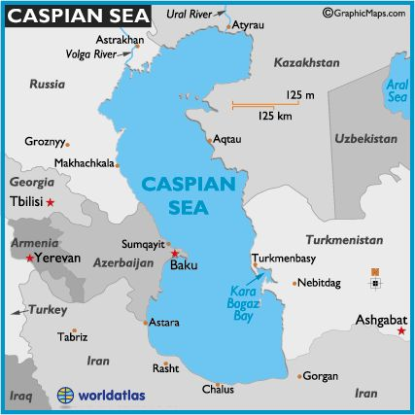閱讀理解

**The Caspian Sea** is between Russia and Iran. At the north end of this large body of water, there is no salt. During the winter it freezes. In the middle and the south end the water is salty and does not freeze.

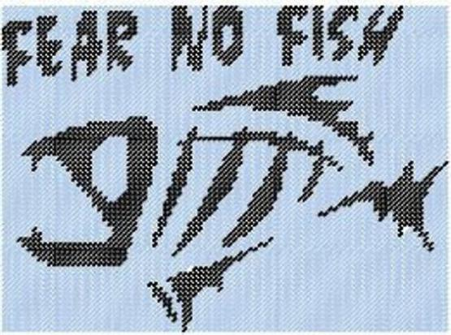**The Dead Sea** is the saltiest body of water in the world. It is nine times saltier than the ocean. Nothing can live in water that is so salty. The land near the Dead sea is very hot and dry. Every day tons of fresh water runs into the sea from rivers that are near it. But it is so hot that the water evaporates before it can help to make the Dead Sea less salty.

1. Which sea is saltier - the Caspian sea or the Dead Sea?

_____________________________________

1. Why would no birds fly over the Dead Sea?

_____________________________________________________________________

1. Where does the fresh water for these seas come from?

_____________________________________________________________________

1. From which end does fresh water enter the Caspian Sea?

_____________________________________________________________________

1. Are there plants growing in the Dead Sea?

__________________________________________________________________

1. Could you make ice cubes by freezing water from the Dead Sea?

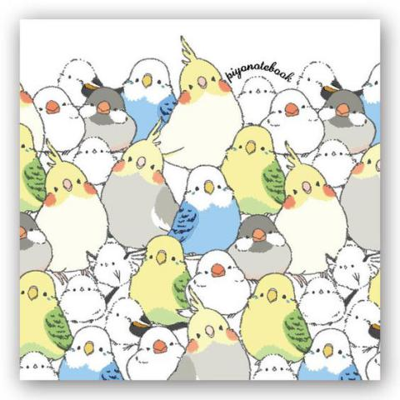_____________________________________

Why or why not? ____________________________________

**Parakeets** are happy little birds. They chirp and chatter all the time. They can learn to talk by listening to people. They will learn to sit on your hand or your head. They are bright colors blue, green, and yellow. They love to play with bells and swings in their cages. They eat seeds and pieces of fruit.

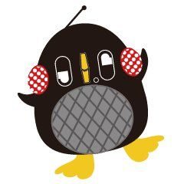The **Mynah bird** is amazing. This shiny, black bird has a sharp, pointed bill. It can talk just like people do. It will repeat almost anything you say. The bird will also use the same kind of voice you use. The mynah bird likes to be around people and becomes friendly very quickly. Mynah birds like to eat bugs and worms.

1. Do all taking birds have the same kind of beak? Explain your answer.

_____________________________________________________________________

1. Why does the mynah bird have a pointed beak?
2. Which birds is the most colorful?

_____________________________________________________________________

1. Which of these birds makes the most noise?

_______________________________________________________________

1. Why would both birds make good pets?

_____________________________________________________________________

1. What would be the bad part about having a pet bird?

## ※ You can look up the books to find the BEST answers.